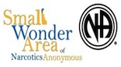

Small Wonder Area of Narcotics Anonymous (SWANA)

AREA SERVICE MINUTES
June 2021
OPENING
The Treasurer, Lisa B., called meeting to order at 4:30 pm. A moment of silence was followed by the Serenity Prayer. The 12 Traditions and 12 Concepts were read. Roll call was taken at 4:35pm by Rebecca S. (see attached Roll Call sheet).

OLD BUSINESS

Minutes:

Elections:
Rebecca S. was elected as Area Secretary.
Edward was elected as Area Treasurer.
Jennifer W. was elected as Public Information Chair.
Kitti S. was elected as Meeting List/ Website Chair.
Charlene was elected as Phone line Chair.
Vacant Positions:
- Area Chair
- Area Co-Chair
- Area Co-Secretary
- Area Co-Treasurer
- RCM1
- RCM2
- Alternate RCM
- Outreach Chair
- Unity & Activities chair
- Literature Chair
- Policy Chair
- Hospitals & Institutions Chair

Motions Voted Upon:

HOME GROUP REPORTS
- First State Survivors on Sunday nigh at 8pm in Claymont is in desperate need of support. Attendance has not been good, it is also in need of home group members and trusted servants.
- The Journey Continues will be revising their format and is in need of support.
- Hump Day Hope will be changing their format from speakers every week to bi-weekly.
- Women’s Meeting on Zoom will be revising their format.

Second roll call was taken by the Secretary (see attached Roll Call sheet).

SUBCOMMITTEE REPORTS
The Chairman called for and received reports from the subcommittees, with a Q&A session following each report. Please see following pages for these reports.

Convention Committee
Meets 2nd Sat of month at10am on Zoom. Meeting ID: 847 8641 9368 Password: SWACNA
Please see attached report

H & I Subcommittee

Literature Subcommittee

Meeting List/Website Subcommittee
Kitti S., Chair (302)
Rebecca S., Co-Chair (302) 373-9694
Please see attached report.

Outreach Subcommittee

Phone Line Subcommittee
SWANAphoneline@gmail.com

Policy Subcommittee

Public Relations Subcommittee

Regional Committee Member (RCM)
Les M., RCM1 (215) 783-6798
Please see attached report.

Secretary

Unity & Activities Subcommittee
Lenore H. (302) 723-5398
Please see attached report.

NEW BUSINESS

Nominations:
- Dionna is nominated for Outreach Chair.
- Justine D. is nominated for Area Chair.
- Aaron H. is nominated for Policy Chair.

Motions:
- The Journey Continues presented a motion regarding monthly meetings, as opposed to bi-monthly. Pros: Every other month schedule was only temporary due to COVID, now that meetings are reopening we could return to the monthly schedule. There were no Cons for this motion.
PLEASE SEE ATTACHED MOTION FORM FOR FURTHER INFORMATION.
- The Journey continues presented a motion regarding JAC and ASC meeting on weekday evening similar to other areas. Pros: It might be a better time to disperse information and updates through the area. It could be a more convenient time. Summer is an easier time to try something different. There were no cons for this motion.
PLEASE SEE ATTACHED MOTION FORM FOR FURTHER INFORMATION.
- Les M. presented a motion to donate $600 (10% of the money in the Small Wonder Area Bank Account) to Region.
- Lisa B. presented a motion to allocated $50 for the Memorial planned for the Area Picnic in July. Motion was voted on and approved, 8 in favor, 0 opposed, and no abstentions.
- A motion and vote was taken to close the meeting.

OPEN FORUM

No open forum took place due to time constraints.

CLOSING

The meeting was closed with a moment of silence, followed by the Serenity Prayer. Meeting concluded at 6:45 p.m.

IN LOVING SERVICE,
Rebecca S., Area Secretary (@gmail.com)
(302-373-9694)
JAC ATTENDANCE
 | PRESENT | ABSENT | PRESENT | ABSENT
Chair |  | X |  | X
Co-Chair |  | X |  | X
Secretary |  | X |  | X
Co-Secretary (vacant)
Treasurer | X |  | X
Co-Treasurer |  | X |  | X
Policy |  | X | X
RCM 1 |  | X |  | X
RCM 2 |  | X |  | X
H&I |  | X |  | X
Literature |  | X |  | X
Public Relations |  | X |  | X
Phoneline |  | X |  | X
Outreach |  | X |  | X
Meeting List/Website | X |  | X
Unity & Activities |  | X |  | X
Convention (Secretary) | X |  | X

AREA SERVICE HOME GROUP ATTENDANCE
 | 1st Roll Call |  | 2nd Roll Call
Home Group | Present/ Voting | Absent | Present/ Voting | Absent
- Addicted to Hope |  | X |  | X
- Almost Heaven |  | X |  | X
- Attitudes In Action |  | X |  | X
- Basic Text | X |  | X
- Be At Your Best |  | X |  | X
- By NA Means Necessary |  | X |  | X
- Clean But Not Straight |  | X |  | X
- Clean Dreams | X |  | X
- Delaware Step Group |  | X |  | X
- Doors Always Open to Recovery |  | X |  | X
- Down Home Group | X |  | X
- Each One Teach One |  | X |  | X
- First State Survivors | X |  | X
- Get It Off Your Chest |  | X |  | X
- Hope for Healing | X |  |  | X
- Hump Day Hope | X |  |  | X
- The Journey Continues | X |  | X
- Just For Today |  |  | X
- Last Chance For Recovery |  | X |  | X
- Living The Steps |  | X |  | X
- Meditations & Steps |  | X |  | X
- Monday Night Recovery |  | X |  | X
- Miracles Happen |  | X |  | X
- A New Way of Life |  | X |  | X
- Recovery In the A.M. |  | X |  | X
- Recovery on the Westside |  | X |  | X
- Saturday Night Live |  | X |  | X
- Simplicity Group |  | X |  | X
- STAR Group | X |  | X
- Step By Step | X |  | X
- Sunday Night Recovery/ Spiritual Connection | X |  | X
- This Is H.O.W. |  | X |  | X
- Three Minutes of Meditation |  | X |  | X
- Time to Live Again |  | X |  | X
- Together We Can |  | X |  | X
- Turn It Over |  | X |  | X
- We Want To Live | X |  | X
- Weekend Survivors | X |  | X
- Women’s Meeting on Zoom | X |  | X

SUBCOMMITTEE REPORTS

SWANA (SMALL WONDER AREA OF NARCOTICS ANONYMOUS)
RCM (REGIONAL COMMITTEE MEMBER)
06/12/21
ON MONTH
5 items were on the agenda the last few months: convention, zonal forum, multi-zonal symposium, regional ins, and motions. There were 9 RCM’s in attendance. Mtg opened with moment of silence, 12 traditions and 12 concepts were read.
I tried to attend the service center board mtg but was not able to attend due to number being incorrect.
FREESTATE REGION CONVENTION
Wayne- convention chair gave the mtg an update on the convention.
Flyers are available.
Registration is up and running on the FSRCNA.ORG website.
Anyone who registered in the previous convention will receive $5 refund (550 persons registered). 71 persons will receive the pre-registration refund.
I did register so it is running, you must register with id and password.
If anyone knows a comedian, a karaoke player, and a jazz group please email me at lcm46@verizon.net.
Attached is the flyer for our area to distribute to mtgs in our area.
The convention program chair Pam is asking for people to give their 4 generation sponsorship Tree and names will go on the wall at the convention. Send me the names and I will forward them to her.
Zones
The next Zonal Forum will be held on zoom in July. Go to the freestate website to get dates and times.
Our RD and RDA is focusing on the WSC, Multi-Zonal Symposium in San Antonio 8/27-29/2021 and MRLT (multi region learning) symposium in Dec 2021. We need support for our own Autonomy Zonal Forum in July.
INSURANCE POLICY
The Region has put together an adhoc committee to investigate the financial impact it is having in all our area having their own insurances. We want to be able to have one policy for all areas in the region. All areas will come back to the region in July with their areas policy to give to the committee.
MOTIONS
The Region voted unanimously to remove the 30 year old H&I handbook and look into updating it in the future.
The motion passed to allocate finances to the RD and RDA for the upcoming symposiums. Allocation was for $1,000.00.
There was amotion to vote from the literature chair (Elyssa) on the SPAD (Spiritual Principles A Day) in September.
There was also a motion to support our phoneline chair (Michael) to set up the YAP application for BMLT (basic mtg list).
There was a motion to continue to proceed with the Public Relations (Ray) billboard project already approved last year for $1,900.00 for 8 weeks per area. The region was holding the monies for the next 2 areas.

In Loving Service
Les M RCM1

SWACNA 14 Minutes

Chair Report - Service is never a solo effort as it is with many other things in life. Our convention body had its meeting today. It has been a while since we had an appointment to reengage our initial commitment to SWACNA XIV. We addressed many open ends of committees and reviewed our updated contracts. We solidified our upcoming July 10th speaker jam. Welcomed John R to the body. Our operations committee has been able to conjure up additional support. As we move forward, enriched by our active involvement, it feels like the band is back together.

Our convention is rescheduled for March 11-13, 2022.

Contacts are signed with the Chase Center and Westin Hotel. The room rates for the Westin will be $129 per night for rooms.

In Loving Service, Anthony R

Treasurers Report Lee S.- There is no change in the bank balance $15,226.54. Everything is cleared in the bank. Still holding the $200 change for the events. Storage is paid through September.

Open Positions are A&G, F&E, Convention info is you know anyone who would like to be in service please let us know.

Subcommittees that need subcommittee members are F&E, Merchandise, Registration, Programming.

We have 3 events scheduled all at St. James in 2 Augustine St. Newport from 12-8
July 10
September 11
November 13

Our next meeting will be July 10, at 11:00 at St. James before the meeting, Live!

In loving service
Roxane B. Convention Secretary

Meeting List/ Website Subcommittee Report
June 27, 2021

The subcommittee has continued its work in updating the website and BMLT to reflect changes to meetings as they reopen. All of the updates that have been received have been posted on the website and changed in the BMLT, with the exception of the home group Clean But Not Straight. There is a question about the location and both members of the subcommittee have reached out to home group members but have not gotten responses. The Home Group Update form is still on the website and the subcommittee kindly asks that any announcements of changes to meetings be made through that form rather than on social media or direct contact with a subcommittee member. It is much easier to update the platforms using this form rather than trying to refer back to text messages or social media posts. The paper meeting list has been updated and was sent to print in June. Home groups were made aware of the new meeting lists being printed but there were ones that did not ask for the new lists and instead have been distributing old ones with outdated information. Due to the distribution of old meeting lists there have been individuals that have contacted the subcommittee about the inaccurate information on them. We are currently preparing the meeting list that will be printed at the beginning of July. It would be greatly appreciated if all home groups could check their meeting information again on the website and send a Home Group Update form if any changes need to be made because we will be using the website information as the basis for the paper meeting list. Home groups will again be notified once the new lists have been printed. The subcommittee would also like to recognize Lisa B. for all of her assistance with the website and for taking meetings off of the Zoom platform that are no longer meeting.

In Loving Service
Kitti S.

Unity & Activities Subcommittee Report
June 27, 2021

This is a friendly reminder that our Area’s annual picnic will be held in person. We are really excited as this is our first in-person event since COVID. The picnic will be held on Saturday, July 24th from 1pm to 6pm at Brandywine Springs Park. If you have any questions or are interested in being of service please contact me at (302) 723-5398.

In Loving Service,

Lenore H.

Treasurer’s Report
June 2021

Just a couple of announcements.
I have renewed our Quicken subscription so that it is now Cloud-based and can easily be transferred to the next treasurer to use online.
A number of meeting facilities have requested Certificates of Insurance prior to reopening. Please contact me if you need one for your facility.

In loving service,
Lisa B.

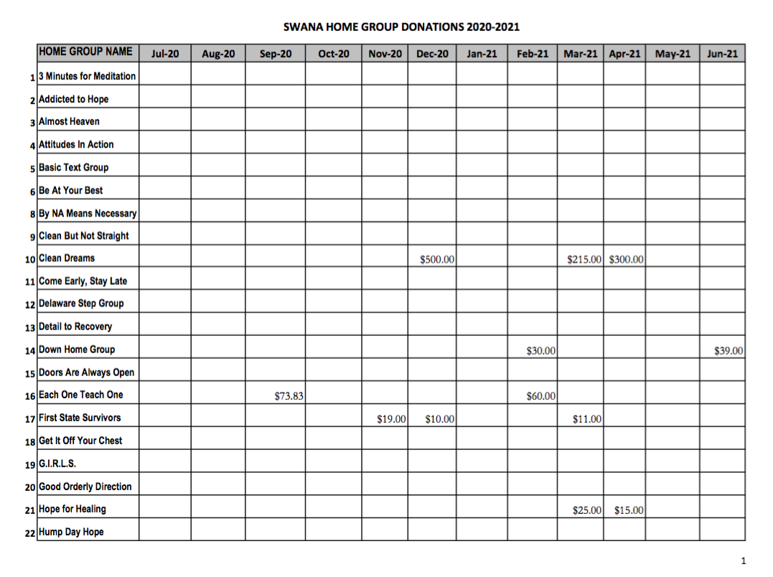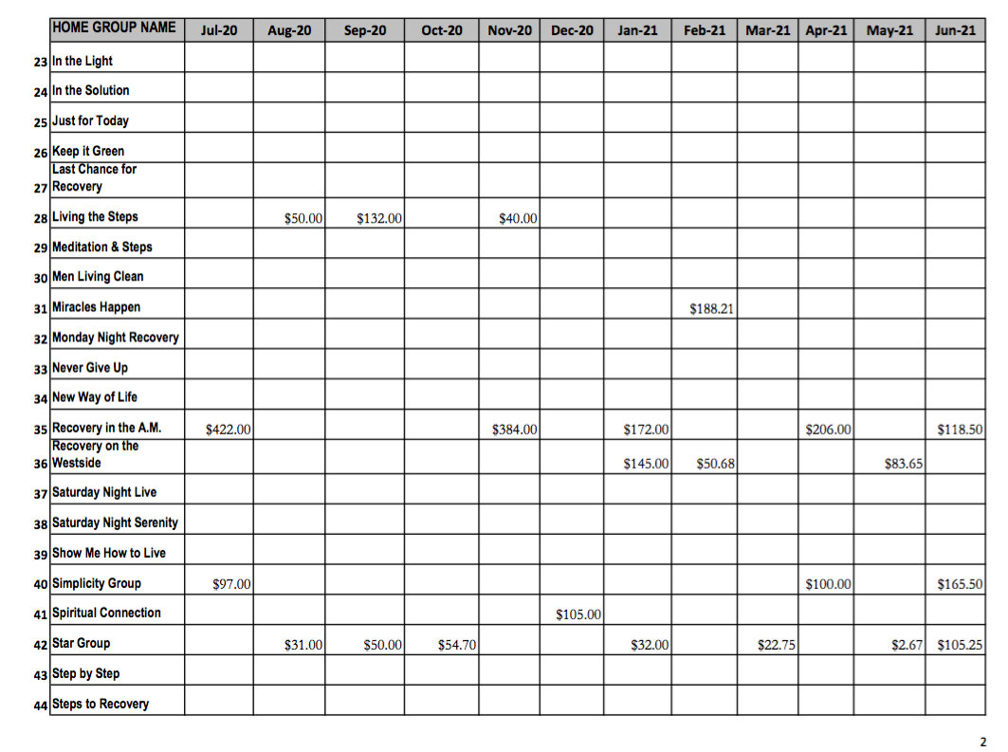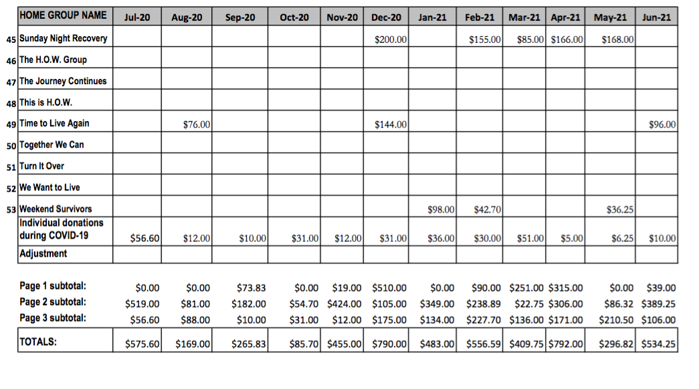

Motions

MOTION FORM
Date: 6/26/21
Individual/Group Making Motion: Lisa B & Kitti S
What Part of Policy Will Be Affected? Page #:_N/A____ Article #: ________ Section #:_______
What Is A Motion?
A motion is the statement of an idea made by a member or group describing a specific practice
that the member/group wants the Area to put into place.

STATE MOTION: To allocate $50 toward the purchase of supplies for creating a memorial setting at the annual SWANA picnic.

50 LED Photo Clips String Lights Holder - Amazon $16.00

Flameless Votive Candles, Flameless, Pack of 24 - Amazon $14.00

Glass vases – Dollar Store 6.00

Faux flowers – Dollar Store 14.00
What Is Intent?
The intent of a motion describes why or how the motion will improve policy, simplify a process, or provide something needed by a committee to fulfill their service commitment.
DESCRIBE INTENT: To provide a way for the Area to honor those we lost during COVID and the lockdown when gatherings were not permitted

SECRETARY USE ONLY:
DISPOSITION OF MOTION | YES | NO | ABSTAIN
( ✔ ) CARRIED | 8 | 0 | 0
( ) FAILED
( ) TABLED
( ) TIE: INDICATE THE CHAIR’S DECISION
( ) RESUBMIT TO GROUPS
( ) SUBMIT TO SUBCOMMITTEE
( ) OTHER

MOTION FORM
Date: 6/26/21
Individual/Group Making Motion: The Journey Continues
What Part of Policy Will Be Affected? Page #:____ Article #: ________ Section #:_______
What Is A Motion?
A motion is the statement of an idea made by a member or group describing a specific practice
that the member/group wants the Area to put into place.

STATE MOTION: To have monthly ASC meetings.

What Is Intent?
The intent of a motion describes why or how the motion will improve policy, simplify a process, or provide something needed by a committee to fulfill their service commitment.
DESCRIBE INTENT: By going back to monthly ASC meetings we will be adhering to policy again as it was only changed temporarily due to COVID.

SECRETARY USE ONLY:
DISPOSITION OF MOTION | YES | NO | ABSTAIN
( ) CARRIED
( ) FAILED
( ) TABLED
( ) TIE: INDICATE THE CHAIR’S DECISION
( ) RESUBMIT TO GROUPS
( ) SUBMIT TO SUBCOMMITTEE
( ) OTHER

MOTION FORM
Date: 6/26/21
Individual/Group Making Motion: The Journey Continues
What Part of Policy Will Be Affected? Page #:_____ Article #: ________ Section #:_______
What Is A Motion?
A motion is the statement of an idea made by a member or group describing a specific practice
that the member/group wants the Area to put into place.

STATE MOTION: To hold ASC meetings on a weekday evening, possibly the 3rd Thursday of the month.

What Is Intent?
The intent of a motion describes why or how the motion will improve policy, simplify a process, or provide something needed by a committee to fulfill their service commitment.
DESCRIBE INTENT: To change ASC to a day and time when more people would be able to attend the meeting, therefore increasing attendance and participation.

SECRETARY USE ONLY:
DISPOSITION OF MOTION | YES | NO | ABSTAIN
( ) CARRIED
( ) FAILED
( ) TABLED
( ) TIE: INDICATE THE CHAIR’S DECISION
( ) RESUBMIT TO GROUPS
( ) SUBMIT TO SUBCOMMITTEE
( ) OTHER

